_______________________________________________________________________

**CSC221 ADVANCED Python Programming**

_______________________________________________________________________

LAB10 DJANGO WEB FRAMEWORK – book application

# Objectives

In this lab assignment, students will learn how to:

* use the Django web framework to create a simple web application
* create Django ‘fixture’ file to import (load) book data into an SQLite database
* create a Django simple web application to display book data

**PRE-REQs:** Install the Django package:

* django

# Instructions

I recommend you create a (new) folder for this week’s lab, for example **Lab10**. This will help you keep your work organized throughout the semester and make it easy to find your work for this course.

This lab is two-part:

**PART A** ~ Using Jupyter Notebook file ***Lab10-CreateDjangoImportData.ipynb***, create a Django **fixture file** from file **classic_books.json**. You will be using this **fixture file** in PART B to import the classic books data into the SQLite3 database used by the Django web application you will create in PART B.

**PART B** ~ Using the instructions in file ***Lab10-CreateDjangoWebApp.docx*** (and the Django web framework tutorials referenced in this lesson), create a simple Django web application to display Classic Books. The application created for this lab re-uses a JSON data file from (similar to those in Lab7) to prime the database used by the application.

**REF**: Homepage for the Django web framework is: <https://www.djangoproject.com/>

The DataCamp & Real Python tutorials included with the lesson material should be helpful in completing this lab exercise.

## More on this Lab …

Because this is a web application running on your machine, you will be expected to submit ***multiple (7) screen captures*** with Lab 10 in order to demonstrate completion of various portions of the lab. Required screen captures are identified within document ***Lab10-CreateDjangoWebApp.docx*** by a wide **DARK RED** boundary and a large black bar header with the screen capture number, for example:

## **SCREEN CAPTURE # 2**

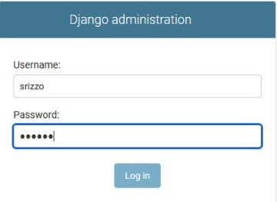

The screen captures must be “pasted” in the Word document provided:

* ***Lab10-DjangoScreenCaptures.docx***

This document contains placeholders for each of the required screen captures.

Unlike previous labs, you will **not** be using Jupyter Notebook to complete PART B of this lab. Much of the Django processing will be done entering commands from the command line via a terminal window and by creating or updating files *using your favorite code editor or IDE*.

The code provided in the lab instructions can be *copied-and-pasted* directly into your code editor. However, be careful when using *copy-n-paste* – tabs/spaces inserted by your editor can often cause Python errors due to indentation errors.

PLEASE take time at the end of each section to reflect on what has just been done.

# Submitting Assignment

Once you have successfully completed PART A & PART B for the lab & gathered the required screen captures, upload (submit) the following files:

* **Lab10-CreateDjangoImportData.ipynb**
* **Lab10-DjangoScreenCaptures.docx**
* **book_import_data.json**
* **django_books.zip ~** zip only the django_books directory
  + DO NOT include your books_env directory!

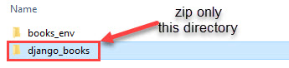

via Blackboard for grading.

# Grading rubric

Total points = 100

* PART A = 25 points
* PART B = 75 points
  + 15 points for screen capture 1 (2 images)
  + 10 points for screen captures 2-7 (1 image each)